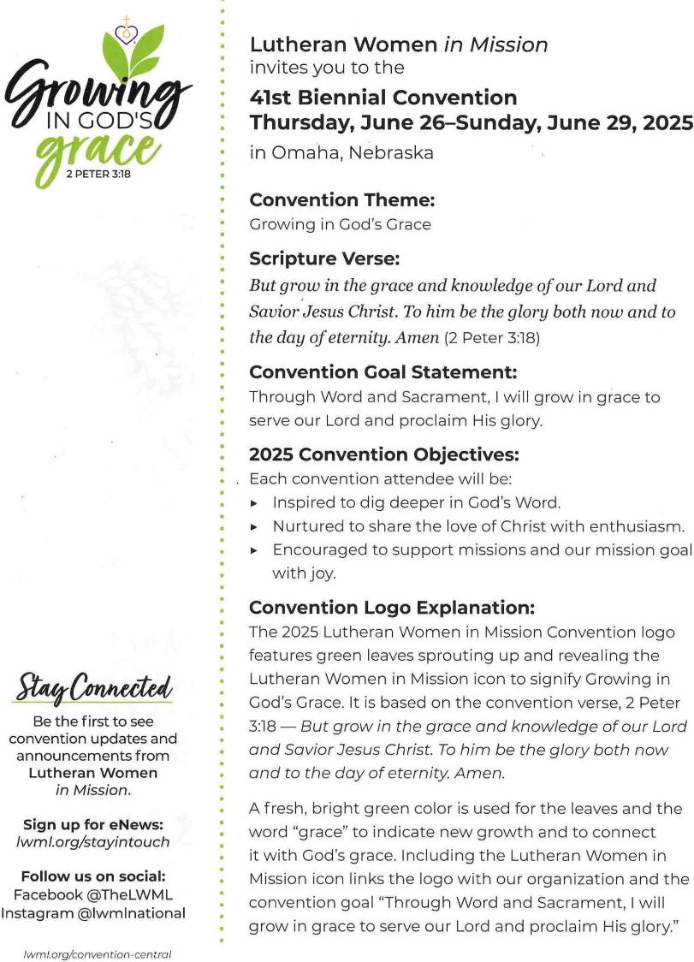 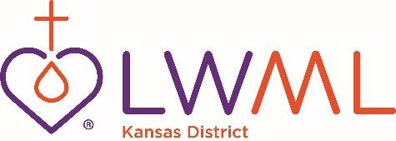

**2025 CONVENTION BUS RESERVATION FORM** LWML Convention, Omaha, Nebraska

June 26-29, 2025

Please print clearly

Name: __________________________________________________________________________________________

Address: ________________________________________________________________________________________

City/State/Zip:____________________________________________________________________________________

Phone Number: ______________________________Cell Phone Number:____________________________________

Congregation/City/State:____________________________________________________________________________

Emergency Contact at Convention:Name/Phone:________________________________________________________

**PREFERENCES**

Number of People in Your Room: ___________

Names of Roommates (if known):

__________________________________________________ ____________________________________________

__________________________________________________ ___________________________________________

The bus trip will start in Wichita on June 25, 2025, with stops in Salina and Topeka. The bus will leave Omaha at the close of convention on June 29, returning to Kansas that day.

A $100 deposit will hold your seat on the bus and is due March 1, 2025. The deposit is NON-REFUNDABLE, unless the bus is canceled. RESERVATION FORM, PARTICIPANT INFORMATION AND RELEASE FORM, AND DEPOSIT MUST BE SUBMITTED TOGETHER. Remainder of cost is due May 1, 2025.

ALL FORMS AND ALL PAYMENTS should be mailed to:

Donna Smith, P.O. Box 194, Council Grove, KS 66846

Make all checks payable to **LWML Kansas District**

Estimated pricing for the bus alone is $283. This price is based on 25 people. If we have more, the price will go down. I will make room reservations for you, once we have been assigned a hotel for our bus by the National Travel Chair. **You will be responsible for paying for your room cost when we check out of the hotel.**

**ALL meals AND convention registration/fees/meals are YOUR responsibility.** Visit [www.lwml.org](http://www.lwml.org) for registration information.

Riding the bus is a great way to make new friends and rekindle old friendships. Onward to Omaha!

God’s blessings,

Donna Smith, Travel Chairman